6SENG006W Concurrent Programming

FSP Process Analysis & Design Form

Name
Student ID
Date

1. FSP Process Attributes

Attribute | Value
Name | COP
Description | Represents a cop managing a junction with 4 traffic lights.
Alphabet | {a, c}.{orangelight, red}
Number of States | 4
Deadlocks (yes/no) | No
Deadlock Trace(s)  (if applicable) | N/A

2. FSP Process Code

FSP Process:
TRAFFIC_LIGHT = (red->redOrange->green->orange->TRAFFIC_LIGHT).

COP = (a.red -> a.orangelight -> c.red -> c.orangelight -> COP ) .

3. Actions Description
A description of what each of the FSP process' actions represents, i.e. is modelling. In addition, indicate if the action is intended to be synchronised (shared) with another process or asynchronous (not shared). (Add rows as necessary.)

Actions | Represents | Synchronous or Asynchronous
a.red | Cop setting lane 1 traffic lights to red. | Asynchronous
a.orangelight | Cop setting lane 1 traffic lights to orange light. | Asynchronous
c.red | Cop setting lane 2 traffic lights to red. | Asynchronous
c.orangelight | Cop setting lane 2 traffic lights to orange light. | Asynchronous

4. FSM/LTS Diagrams of FSP Process
Note that if there are too many states, more than 64, then the LTSA tool will not be able to draw the diagram. In this case draw small diagrams of the most important parts of the complete diagram.

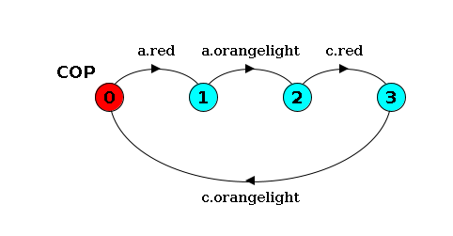

5. LTS States
A description of what each of the FSP process' states represents, i.e. is modelling. If there are a large number of states then you can group similar states together &/or only include the most important ones. For example, identify any states related to mutual exclusion (ME) & the associated critical section (CS), e.g. waiting to enter the CS state, in the CS state(s), left the CS state. (Add rows as necessary.)

State | Represents
0 | All traffic lights start orange and cop is waiting to change the Lane 1 traffic lights to red.
1 | Traffic lights in Lane 1 are red and cop is waiting to change it to orange.
2 | Traffic lights in Lane 2 are orange and cop is waiting to change it to red.
3 | Traffic lights in Lane 2 are red and cop is waiting to change it to orange.

6. Trace Tree for FSP Process
The trace tree for the process. Use the conventions given in the lecture notes and add explanatory notes if necessary.

